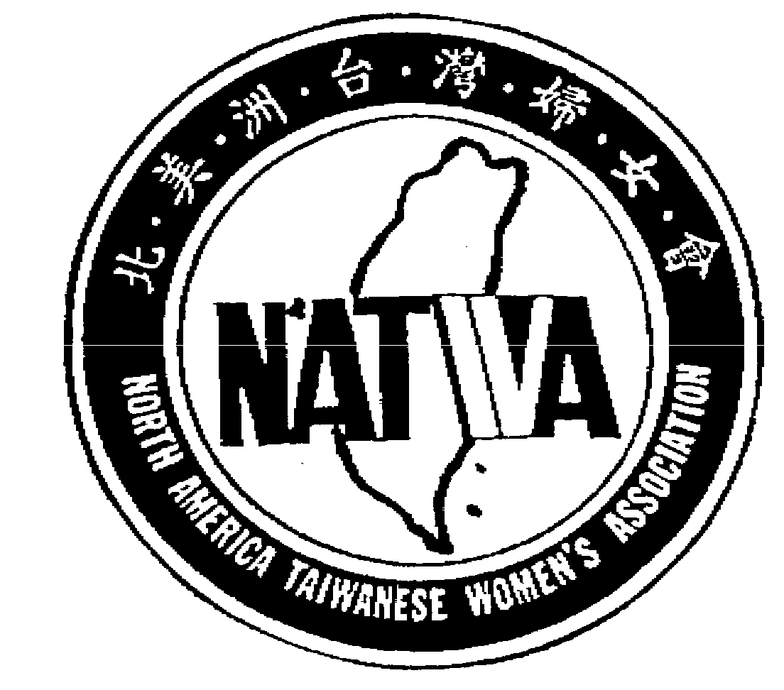
北美洲台灣婦女會

North America Taiwanese Women’s Association
www.natwa.com

REQUEST FOR SPEAKER BUREAU SERVICES
(2023~2024)

NAME OF REGION OR LOCALCHAPTER:

MEETING INFORMATION
Type / Purpose：
Date /Time：
Location： |  | # of people anticipated：

SERVICE REQUESTED
Speaker： |  | Length of Speech：
Topic：
Additional information：

SUBMITTED BY
Name： |  |  |  |  | Position：
Address | No. | Street
Address | City | State |  |  |  | Zip | -
Email Address： |  |  |  | Telephone：

Complete and e-mail to NATWA Fund Chair

Julia Chang張秀滿

NATWA33.J@gmail.com

