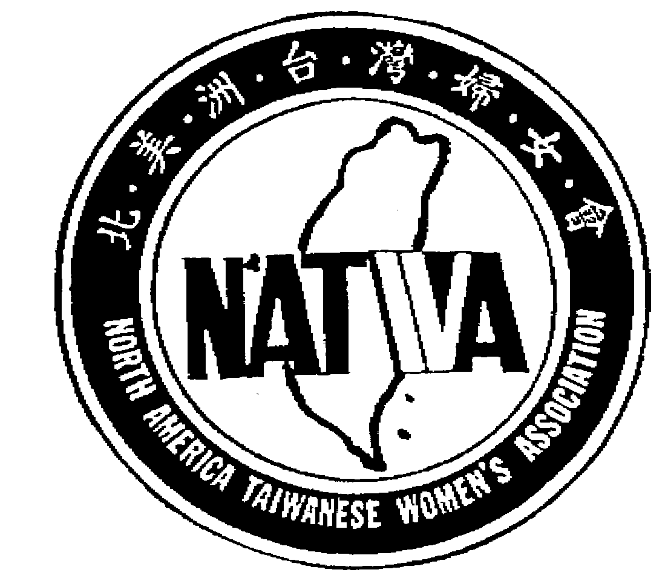
North America Taiwanese Women’s Association
北美洲台灣婦女會
2023-2024 PROPOSAL FORM
If there is any question, please contact 蘇郁璁 Sophia Su natwasecretary@gmail.com
Submitter
Name |  |  |  | Date
Address | Phone |  |  | Email
Proposal
Name/Objective

Attach a separate sheet if necessary
Detail Description

Attach a separate sheet if necessary
Estimate Cost

Attach a separate sheet if necessary
Timeline

Attach a separate sheet if necessary
Submit your proposal
Office use only
Assigned Proposal #: |  |  | Date:
Proposal Reviewing Result:
____ 1. Proposal accepted – Forward to board  members for approval  ____2. Proposal Revision/Clarification  Required |  | Signature(s)
 |  | Date:
Comments/Action Items:

