北美洲台灣婦女會
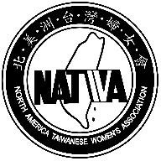

North America Taiwanese Women’s Association
www.natwa.com
A federally registered and non-profit tax exempted organization

Donation Form
Please Specify:
General Donation
To Support NATWA Scholarship Program
To Caring for Soldiers

Please make the check payable to “NATWA” and mail it with this form to

NATWA Treasurer

Carol Shuck 林玉英
26010 Kaywood Drive, Escondido, CA 92026 USA
1-760-743-1060 (USA)
or
Ginny Lin 林儀君
11031 Granville Avenue, Richmond, BC, V6Y1R7 Canada
1-604-828-3888(Canada)

聯絡E-Mail : linginny@gmail.com

Donator Information:

Name: Address: ______________________________________
Phone number: E-mail: ____________________________
Donations Amount: $
NATWA internal use only

Date received amount received signature

