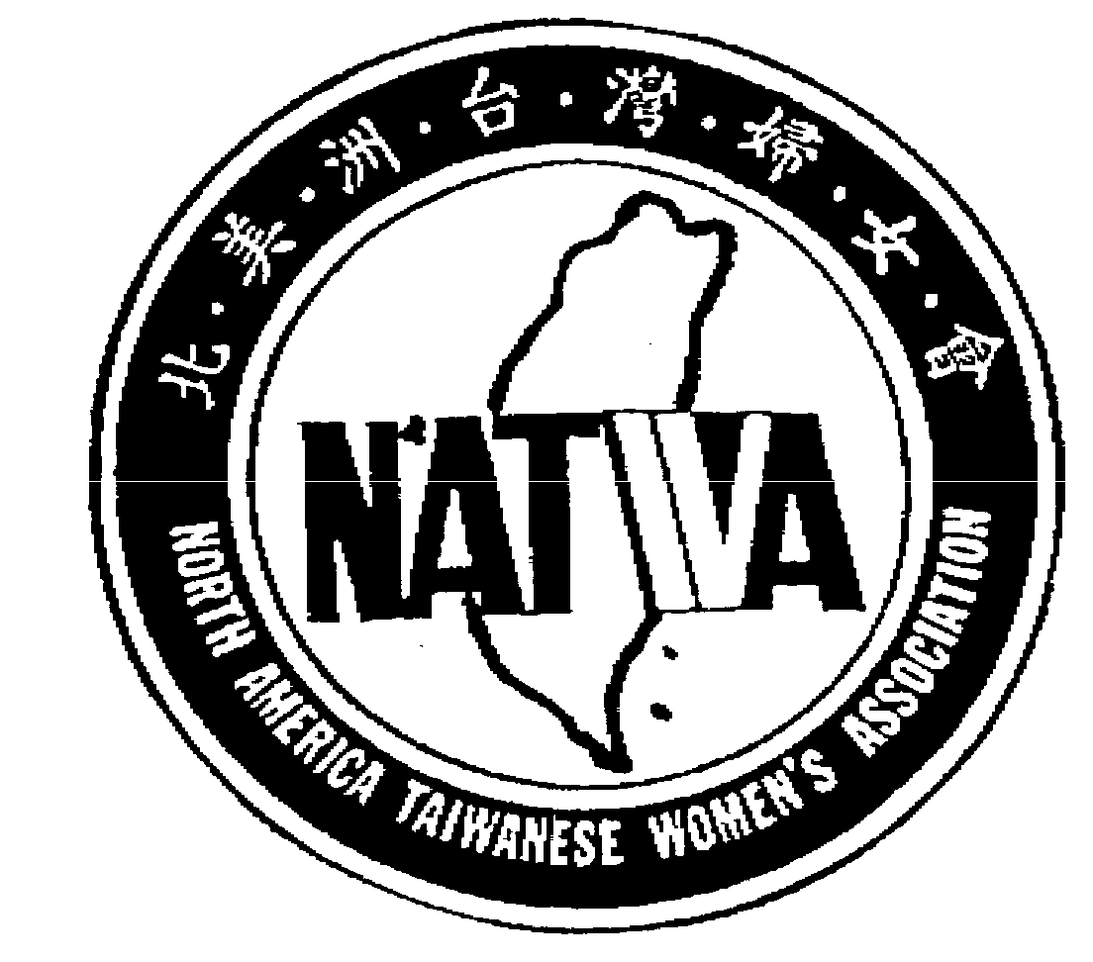
北美洲台灣婦女會

North America Taiwanese Women’s Association
www.natwa.com
REQUEST FOR SPEAKER BUREAU SERVICES (2022~2023)

NAME OF REGION OR LOCAL CHAPTER:

MEETING INFORMATION
Type / Purpose：
Date / Time：
Location： |  | # of people anticipated：

SERVICE REQUESTED
Speaker： |  | Length of Speech：
Topic：
Additional information：

SUBMITTED BY
Name： |  |  |  |  | Position：
Address | No. | Street
Address | City | State |  |  |  | Zip | -
Email Address： |  |  |  | Telephone：

Complete and mail to NATWA Fund Chair

Jacy Chen陳彩雲
490 Greenwich Street
New York, NY 10013

Or email to
NATWA2020@gmail.com

