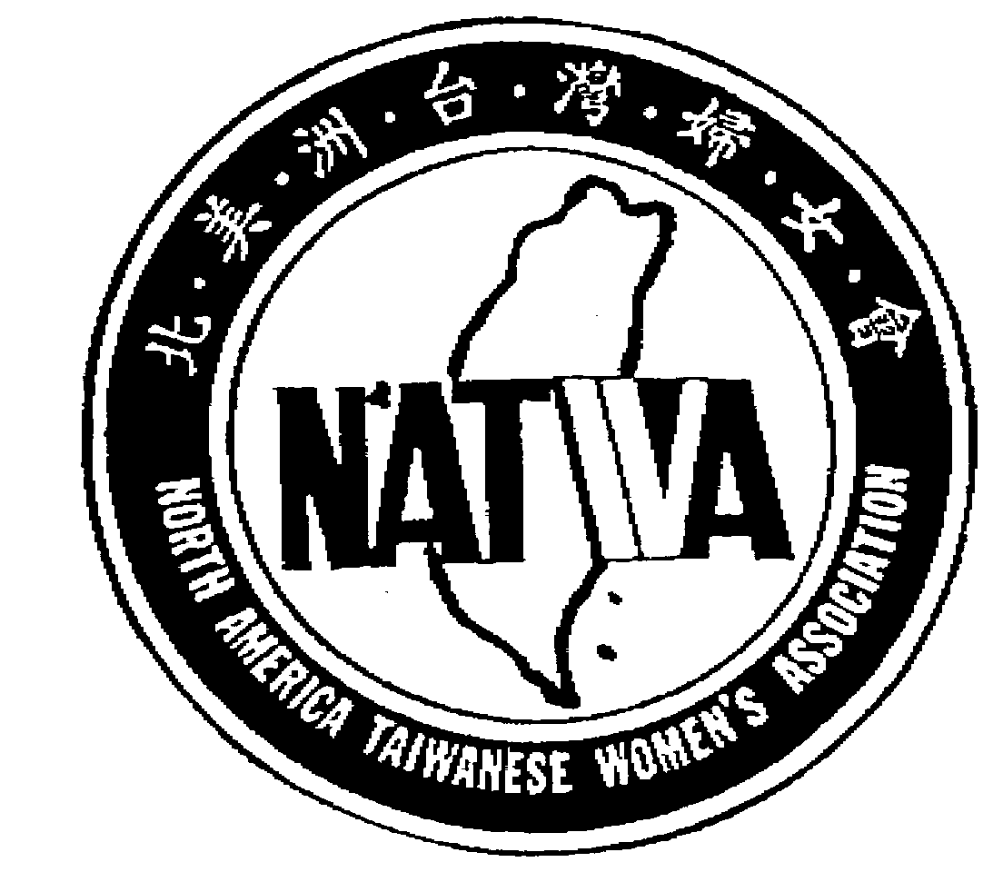
North America Taiwanese Women’s Association
北 美 洲 台 灣 婦 女 會
2022-2023 PROPOSAL FORM
Submit your proposal to NATWA Secretary – Linda Wu 林承芳
NATWASECRETARY@gmail.com

Submitter
Name |  |  |  | Date
Address | Phone |  |  | Email
Proposal
Name/Objective

Attach a separate sheet if necessary
Detail Description

Attach a separate sheet if necessary
Estimate Cost

Attach a separate sheet if necessary
Timeline

Attach a separate sheet if necessary
Office use only
Assigned Proposal #: |  |  | Date:
Proposal Reviewing Result:
____ 1. Proposal accepted – Forward to board  members for approval  ____2. Proposal Revision/Clarification  Required |  | Signature(s)
 |  | Date:
Comments/Action Items:

