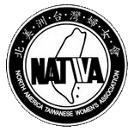
北美洲臺灣婦女會
North America Taiwanese Women’s Association
2 Williams Dr.
Moraga, CA 94556

Invoice No.:

To:_____________________ Date______________

For: __full page __half page __ quarter page __ back page (black) __ back page (color)

Total due:________

NATWA appreciates your advertisement in our four annual publications, which are included membership directory, NATWA magazine, and annual convention program book. Thank you very much for your support.

NATWA advertising rates:

Full Page | US$350.00
Half Page | US$250.00
Quarter Page | US$150.00
Back Page – Black/White | US$600.00
Back Page – Color | US$1,000.00

Please make your check payable to NATWA and mail it to:
Ms. Nancy Yang
2 Williams Dr.
Moraga, CA 94556

